**SinMap:**

SINMAP (Stability Index Mapping) is an Arc View extension that implements the computation and mapping of a slope stability index based upon geographic information, primarily digital elevation data.

SinMap uses threshold limit raised by geo event tool.

**Geo Event:** Tool raises geo event if the rainfall exceeds threshold limit. The threshold limit for SinMap as follows.

Yesterday actual + Today IMD Prediction > 80.0 mm or

Tomorrow IMD Prediction + Today IMD Prediction > 80.0 mm

First it identifies district as per above rule and creates SinMap using TauDEM tool.

**Software Requirement:**

* TauDEM 5.3
* Arcgis 10.0

1. **Add SINMAP Tool to ArcMap.**

Customize > Customize mode > Commands > [Select_Name] e.g.: KSDMA > SINMAP.

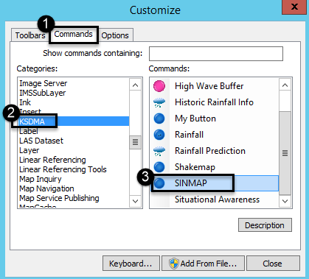

Now drag and drop SINMAP tool to your toolbar.

**Activate the TauDEM Toolbox in Arc GIS:**

* Open ArcMap/ArcCatalog. If the Arc Toolbox Window is not open, click on the "Show/Hide Arc Toolbox Window" icon in the Standard Toolbar.
* Right click on Arc Toolbox at the top of the window. Select Add Toolbox.

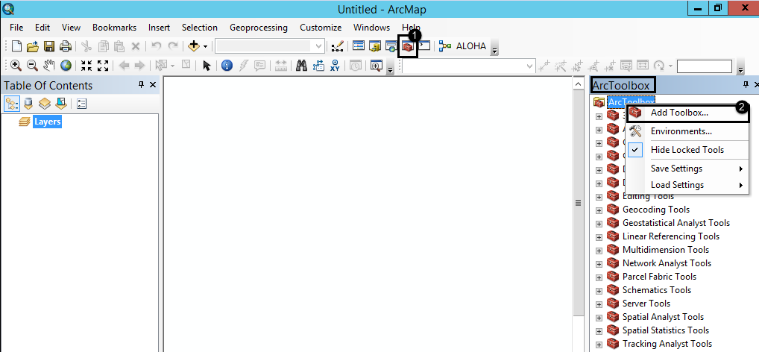

* Browse to the TauDEM install directory (by default, this is: C:\Program Files\TauDEM\TauDEM5Arc).
* Click on the TauDEM Tools.tbx file, and click Open.

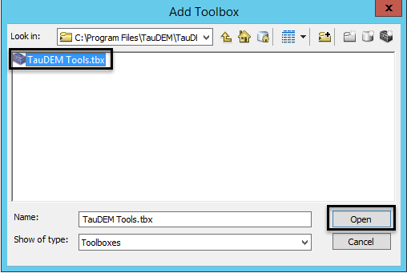

* Load [.tif] file into ArcMap.

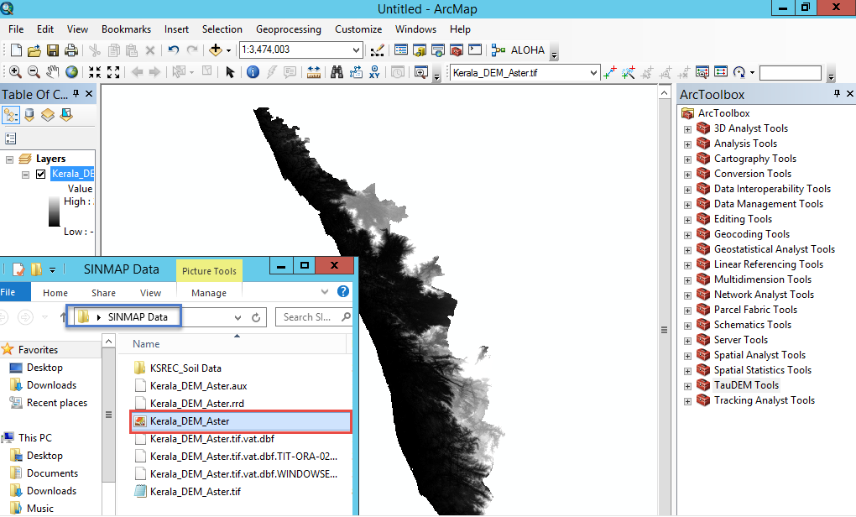

* Use **Pit Remove** TauDEM function.

Pits are grid cells surrounded by higher terrain that do not drain. Pit Remove creates a hydro logically correct DEM by raising the elevation of pits to the point where they overflow their confining pour point and can drain to the edge of the domain.

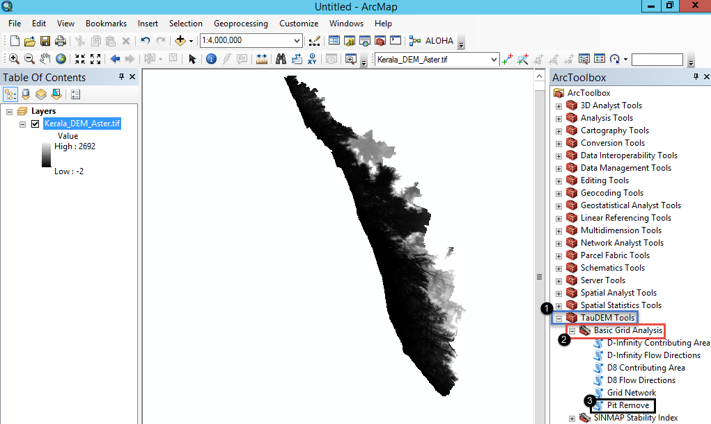

* Select **Kerala_DEM_Aster.tif** for the Input Elevation Grid.   
  Note that the Output Pit Removed Elevation Grid is automatically filled with Kerala_DEM_Asterfel.tif following the file naming convention.

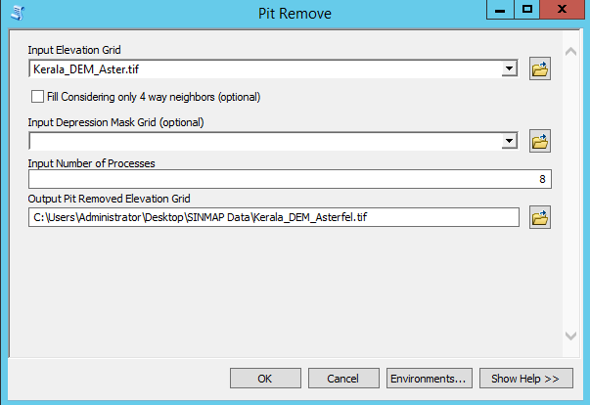

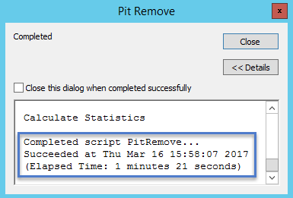

* Next run **D-Infinity Flow Direction** function.

This function is starting point for all D-Infinity work. It calculates D-Infinity flow directions for use in other TauDEM functions requiring D-infinity flow direction input

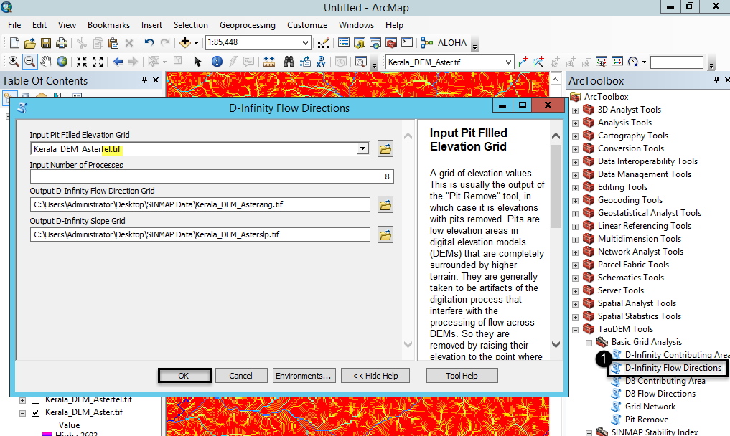

This run may take on the order of 59 minutes to complete.

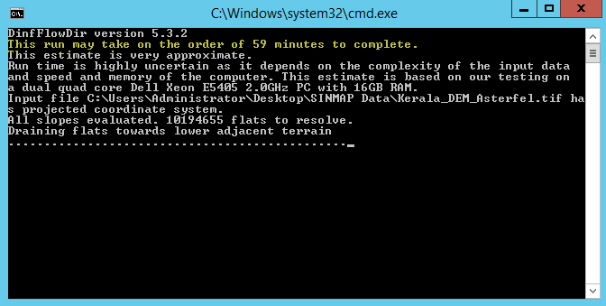

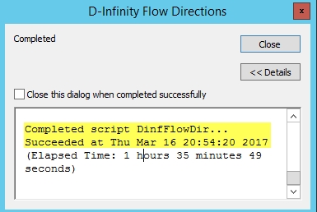

File name suffix [ang.tif] & [slp.tif] is illustrated.

* Next run **D-Infinity Contributing Area** function.

This function evaluates contributing area using the D-Infinity model based on flow being shared between grid cells proportional to the angle to the steepest down slope direction. This is designed to represent specific catchment area within dispersed flow over a smooth topographic surface.

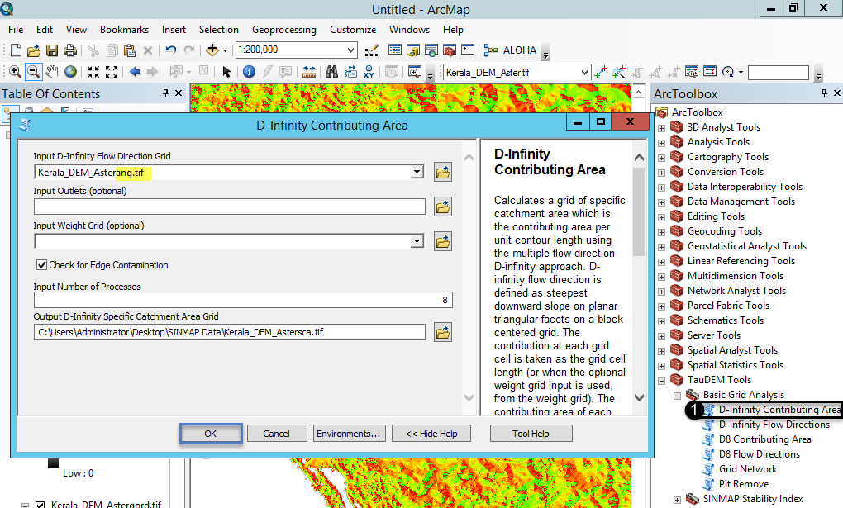

This function results specific catchment area obtained from the D-Infinity contributing area function.

File name suffix [sca.tif] is illustrated.

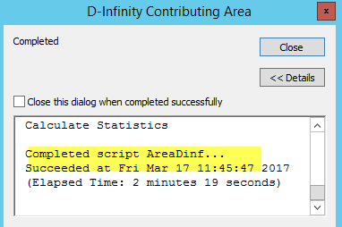

* Next run **Create Parameter Region Grid** function

Input (Main DEM file)

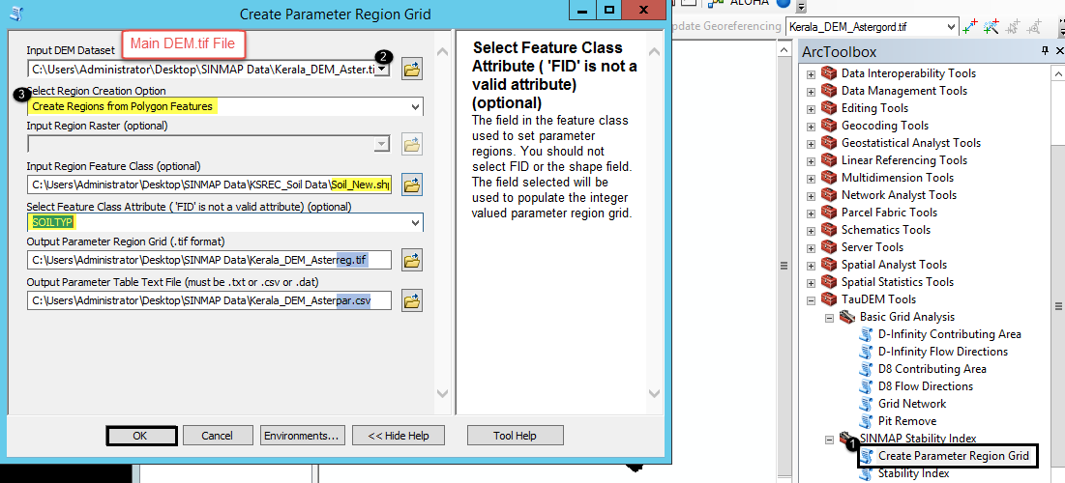

File name suffix [reg.tif] & [par.csv] is illustrated.

* Next run **Stability Index** function.

Input files to stability Index function are:

File name suffix with **(slp.tif)**, **(sca.tif)**, **(reg.tif)** and **(par.csv)**.

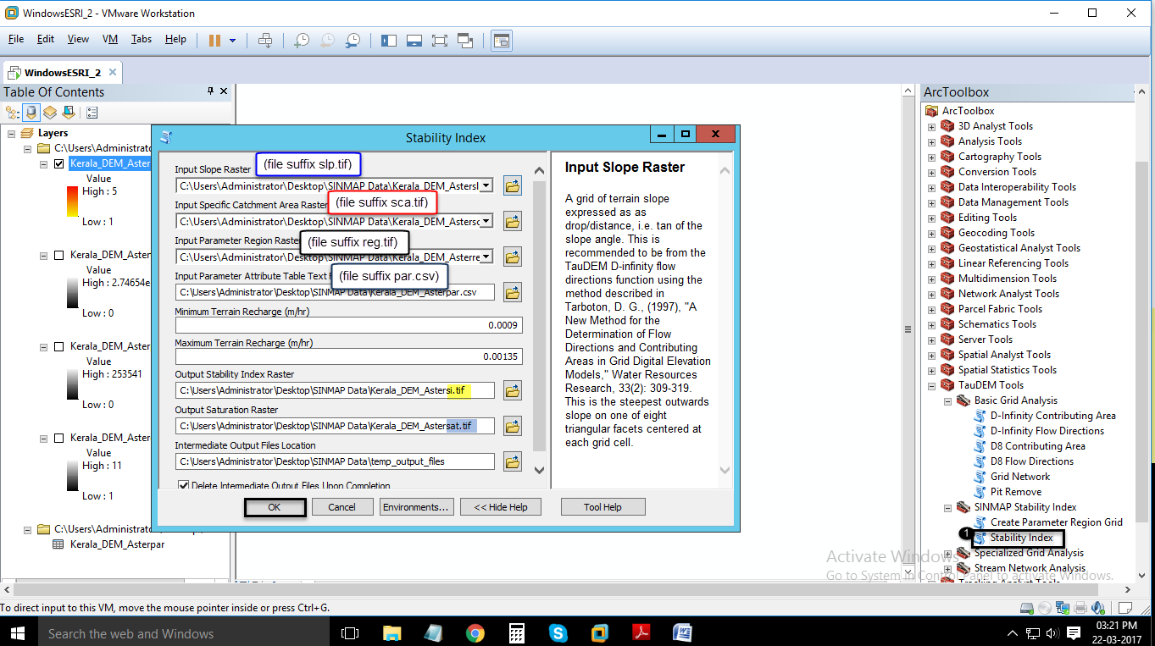

**SINMAP .NET Code Flow:**

By clicking on SINMAP Button it will redirect to **onClick( )** Method of class **btnSINMAP**

Where 2 more methods are defined

Common.clsUtility.GetConfiguration(); and GPSINMAP.clsLandSlide.CheckThresholdLimit();

On the successful completion it will display message box stating “SINMAP COMPLETED”.

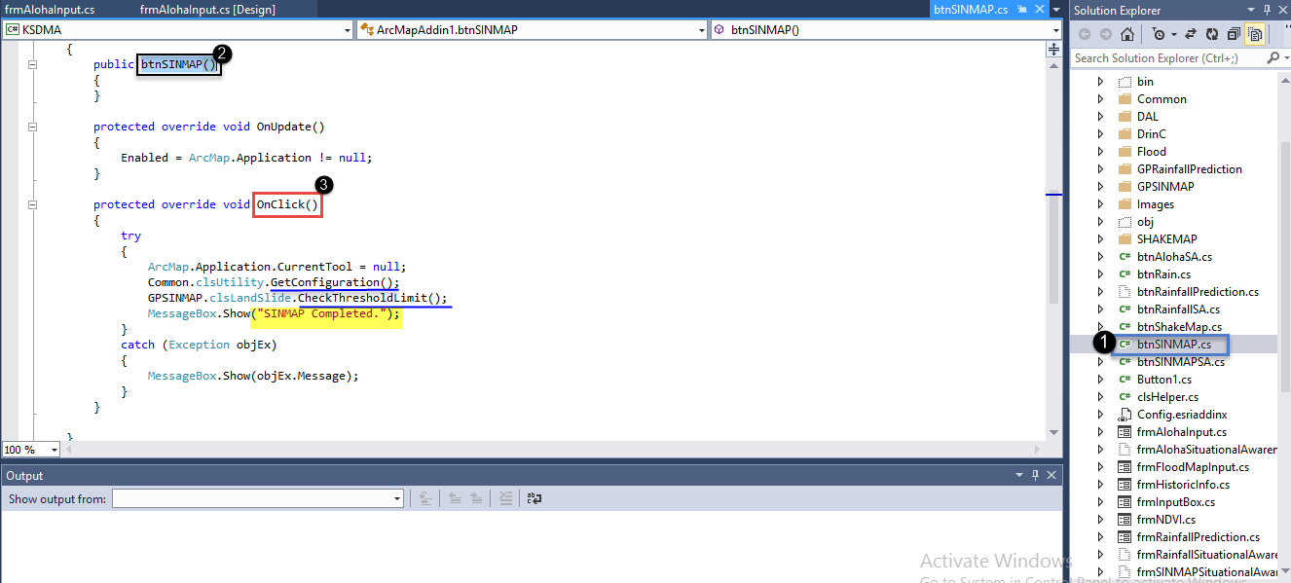

**CheckThresholdLimit()** Method is used to check threshold limit for land slide prediction.

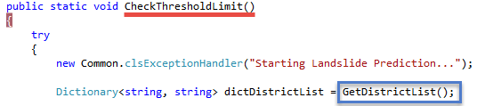

To get districts which are exceeding threshold limit we’ll use **GetDistrictList( )** Method.

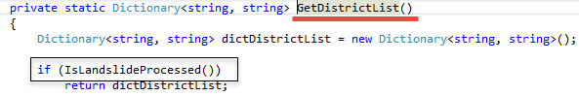

Here it will check for the existing data by using **IsLandslideProcessed( )** Method.

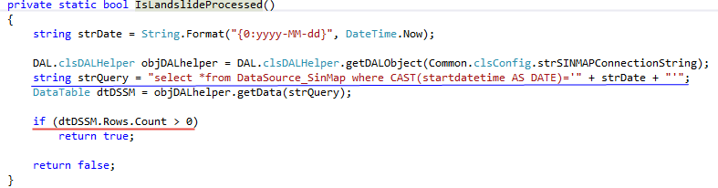

After this the process will take Yesterday’s actual rainfall value, Today’s & Tomorrow’s predicted rainfall values from IMD_table as input. And it will check for the sum of rainfall value if it is greater than the threshold value or not by

**(Yesterday’s actual rainfall+ today’s predicted rainfall) >=80**

**(Today’s predicted rainfall + Tomorrow’s predicted rainfall) >=80**

If the value matches then it will add the district name and the sum of the respective rainfall values to the dictionary and will return the district names.

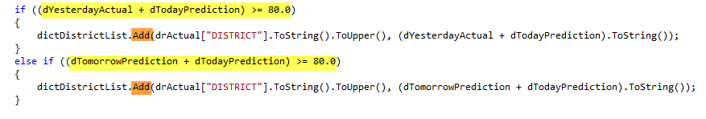

After this it will check for the next condition.

5.png

If the above condition satisfies then the code will flow to **GetCategory()** Method where it will check and return the category list from configuration file.

**<SinmapThreshold Value="High=0-3(50);Medium=4-7(80);Low=8-10(100)" />**

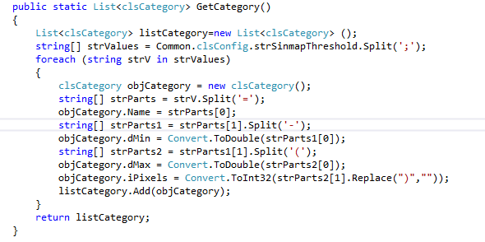

Next it will run **DeleteSINMAPFiles( )** Method to delete the output files for further process.

Next it will run **CreateFileGeoDB(strFileGeoDB)** Method to Create file geodb (with the given format) to process SINMAP flow.

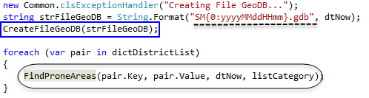

Next it will run **FindProneAreas( )** Method to Find the prone areas exceed the threshold limit.

Here we will use **GenerateSINMAP( )** Method to generate SINMAP from TauDEM software.

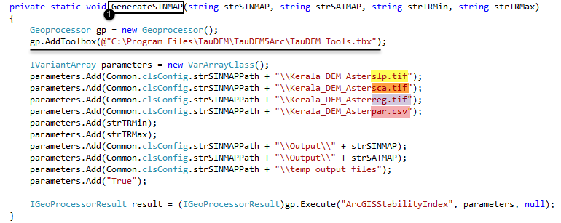

Next code flows to **GetFeature( )** Method to get feature ("OBJECTID, SHAPE") from given feature class.

After this we will use **ExtractRaster( )** method to Extract the given raster to district extent. And **ConvertRaster2Point( )** Method to Converts the given raster file into point feature class.

Next we will use **GetLandslideFeatures()** Method to get list of land slide prone areas in gen Taluk. And **GetVillageName( )** Method to get village name from given point.

Here we are using **GetCategoryTable( )** Method to get data table from category list.

This data table is having 2 columns Name (High/Medium/Low) and Count (initially 0).

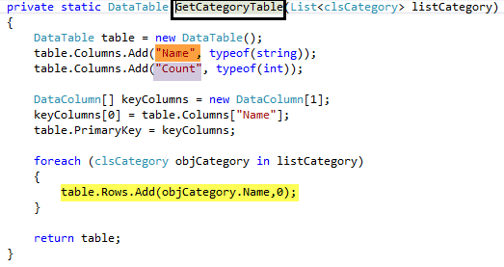

Next we will execute **GetPixelCount( )** Method to get the pixel counts in given land slide prone area. Here it will check for the pixel count, if it is having some value then it will check for the effect percentage and it will execute **RaiseEvent( )** Method.

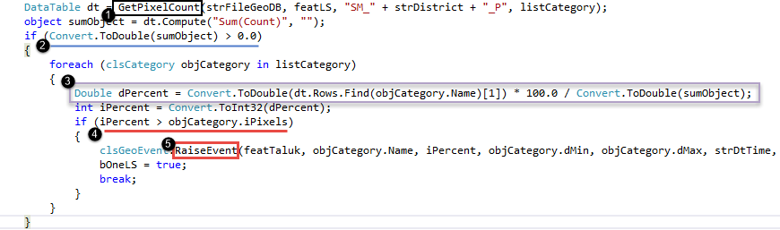

Here we will use **GetGeographicPoint( )** Method to get geographic point from X and Y. And **Common.clsExportMap.Execute( )** Method to export the map for given geo event and Taluk.